RESUME
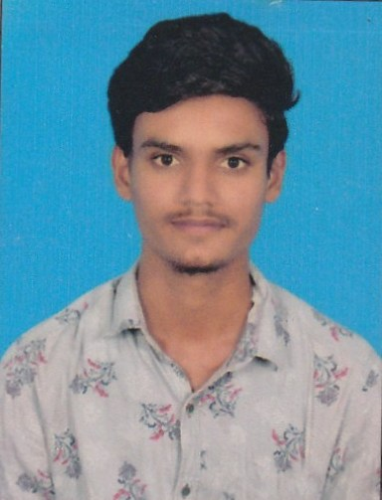

V.Bass Kannan
S/O P.Vengadasalam,
5/58,East Street,
P.Kosavapatti,
Vedasandur E–Mail : bassvenkat1998@gmail.com
Dindigul-624802 Mobile No: 8754666640

OBJECTIVE:

To pursue a flourishing career and willing to work with innovative techniques, thereby availing a mutual enhancement for the company and myself.

EDUCATIONAL QUALIFICATION:

COURSE | INSTITUTION | BOARD/  UNIVERSITY | YEAR  OF PASSING
B.Sc ( IT ) | G.T.N Arts College, Dindigul. | Madurai Kamaraj University | 2019
HSC | Government Higher Secondary School,  Thennampatti. | State Board | 2016
SSLC | CSMA Higher Secondary School,  M.M Kovilur | State Board | 2014

AREA OF INTEREST:

- NETWORKING

- JAVA

PROJECTS :

Project Name : Auto Mobile Agency
Roll : Programmer
Team Size : 2
Project Duration : 5 Months
STRENGTHS :

- Patience
- Dedication Towards
- Being Positive

EXPERIENCE:

- Shanthi Feeds Pvt Ltd Dharapuram Tirupur.
3 Years Preparatory Department.

PERSONAL PROFILE:

DATE OF BIRTH : 24-08-1998

AGE : 23 Yrs

GENDER : MALE

MARITAL STATUS : UN MARRIED

NATIONALITY : INDIAN

FATHER’S NAME : P.VENGADASALAM

LINGUISTIC ABILITIES

(Speak, Read, and Write) : TAMIL, ENGLISH

(Speak) : TAMIL, ENGLISH

DECLARATION:

I solemnly declare that all the above given information is true and correct to the best of my knowledge.

PLACE: Dindigul SIGNATURE

DATE : 23/11/2021 (V.Bass Kannan )

